## **Executive Summary**

The city of NY identified a potential issue of property tax fraud within their jurisdiction. They lack a method to uncover fraudulent activities and are unable to manually review their extensive and disorganized dataset consisting of approximately one million property records, each with 32 fields. Many of these records contain missing fields, making the task even more challenging.

To address this problem, we are developing an unsupervised algorithm capable of efficiently examining the vast property record database to identify potential instances of tax fraud. Specifically, the algorithm will focus on detecting cases where individuals manipulate property characteristics to underpay taxes. This entails identifying unusual property values associated with the listed characteristics of each property. By implementing an algorithm to automate the detection process, we can improve efficiency and accuracy in identifying potential tax fraud cases. This will enable the city to take appropriate actions against those found guilty of misrepresenting property characteristics and underpaying taxes.

The records in the dataset are sorted based on a combined score, and the top records are the potentially fraudulent records which we investigate to understand why they are considered suspicious and whether they are legitimate. We also create heatmaps using the Z-scaled variables to help visualize which variables contribute to the high scores. Heatmaps provide a graphical representation of the relationships between variables, showcasing the variables responsible for driving the high scores in the dataset. This visualization aids in understanding the underlying patterns and identifying the specific variables that contribute to the unusual records. By analyzing the Z-scaled variables and utilizing heatmaps, we can effectively pinpoint the variables with unusual values, allowing for further investigation and exploration of these exceptional records.

## **Data Description:**

**Dataset Description:** The dataset is the Property Valuation and Assessment Data released by the Department of Finance and consists ofReal Estate Assessment Property data that has 1070994 records and 32 fields. It has 14 numeric fields and 18 categorical fields.

**Summary Tables:**

**Numeric Fields:**

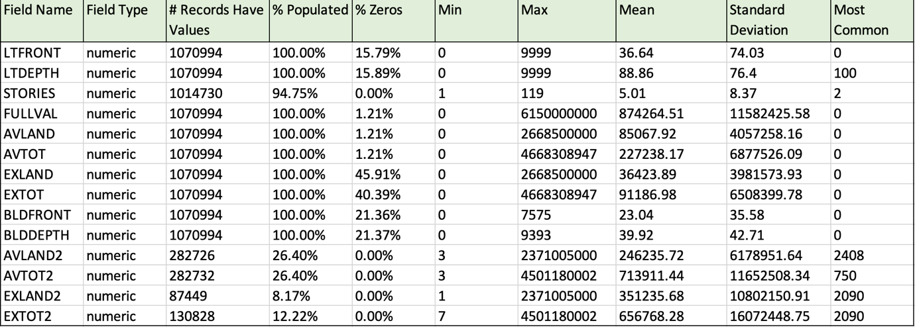

**Categorical Fields:**

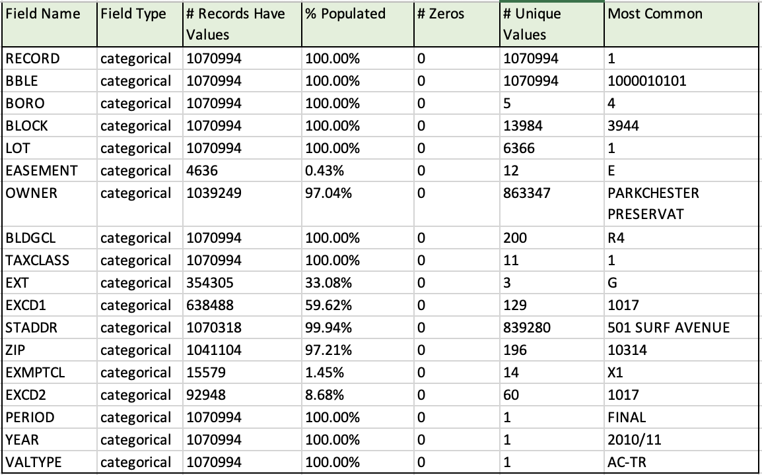

Where:

% Populated: percentage of records present

# Zeros: Number of zeros

# Unique Values: Number of unique values

**Data Types of the Fields**

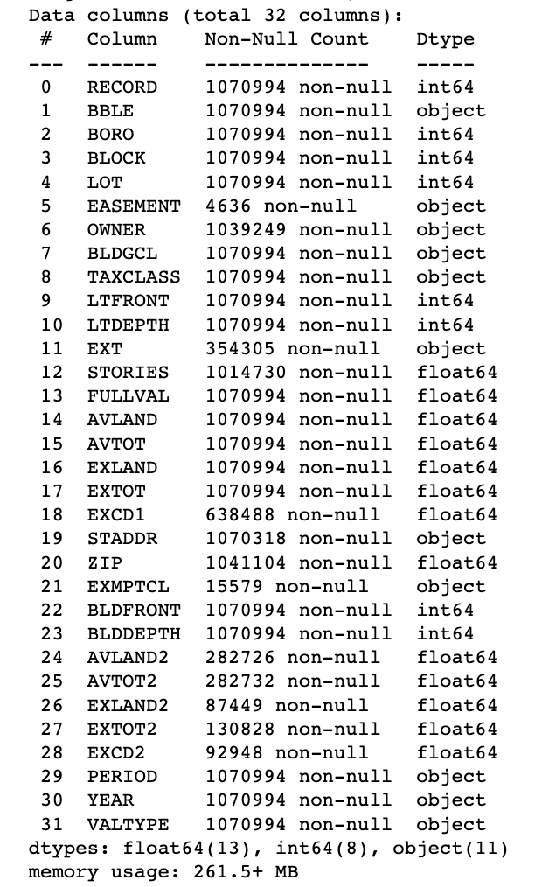

## **Data Cleaning**

##### Data Exclusions

During data exclusion process, properties that were not of interest were removed.

* removed the records with easement type as government where U = U.S. Government and 1 record was removed consequently.
* created a list of owners so as to exclude records with 'DEPT ', 'DEPARTMENT', 'UNITED STATES','GOVERNMENT',' GOVT ', 'CEMETERY' in owner name. Length of this list = 263 and some examples from the list are shown below.

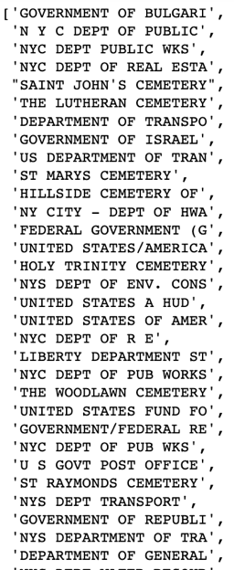

* We also looked at the most frequent owners as this might show some other properties, we aren't interested in. Some examples are shown below.

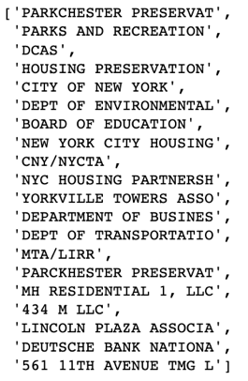

* To the list of owners we were excluding, we added additional owners that weren’t needed such as 'THE CITY OF NEW YORK', 'NYS URBAN DEVELOPMENT', 'NY STATE PUBLIC WORKS', 'PORT AUTHORITY OF NY', 'NEW YORK STATE OWNED', NYC HIGHWAY DEPT'
* The total number of records removed using the list of owners to be excluded: 26500

##### Data Imputation

Values are imputed while noting that we don’t want these filled-in values to set off the alarms for anomalies, so we want them to be neutral. So, we try to fill in missing fields with the most typical value for that field for that record.

## Missing ZIP values imputed with the following logic:

First, we determine the number of missing zip codes. If there are any missing values, replace them with 0 and count the occurrences. The count is 20,431. Additionally, identify the number of missing values for 'BORO' and 'STADDR', which are 0 and 364, respectively. Combine the 'staddr' and 'boro' columns into a new column called 'staddr_boro'. To accomplish this, concatenate the values. Create a dictionary that links zip codes with 'staddr_boro' values. Utilize this dictionary to fill in 2,832 missing zip codes in the dataset.

Assuming the data is already sorted by zip code, if a zip code is missing and the preceding and succeeding zip codes are identical, replace the missing value with that zip code. This process fills in 9,491 missing zip codes. For the remaining 8,108 missing zip codes, simply use the zip code from the previous record to fill them in.

Missing FULLVAL values imputed with the following logic:

Since there were no null values, it was assumed that the 0 values represented missing data. Therefore, the 0 values were replaced with NaN values. By doing this, it was discovered that there were 10,025 missing values.2718 missing values in the 'FULLVAL' column filled by the logic of taking the mean value of that column within each group defined by the unique combinations of 'TAXCLASS', 'BORO', and 'BLDGCL'. This approach allows missing values to be imputed with more relevant values based on the characteristics of each group.

6921 missing values in the 'FULLVAL' column filled by the logic of taking the mean value of that column within each group defined by the unique combinations of 'TAXCLASS', and 'BORO'. This approach allows missing values to be imputed with more relevant values based on the characteristics of each group.

386 missing values in the 'FULLVAL' column filled by the logic of taking the mean value of that column within each group defined by the unique combinations of 'TAXCLASS'. This approach allows missing values to be imputed with more relevant values based on the characteristics of each group.

#### Missing AVLAND values imputed with the following logic:

#### Since there were no null values, it was assumed that the 0 values represented missing data. Therefore, the 0 values were replaced with NaN values. By doing this, it was discovered that there were 10,027 missing values. 2720 missing values in the ' AVLAND' column filled by the logic of taking the mean value of that column within each group defined by the unique combinations of 'TAXCLASS', 'BORO', and 'BLDGCL'. This approach allows missing values to be imputed with more relevant values based on the characteristics of each group.

#### 6921 missing values in the ' AVLAND' column filled by the logic of taking the mean value of that column within each group defined by the unique combinations of 'TAXCLASS', and 'BORO'. This approach allows missing values to be imputed with more relevant values based on the characteristics of each group.

#### 386 missing values in the 'AVLAND' column filled by the logic of taking the mean value of that column within each group defined by the unique combinations of 'TAXCLASS'. This approach allows missing values to be imputed with more relevant values based on the characteristics of each group.

#### Missing AVTOT values imputed with the following logic:

#### Since there were no null values, it was assumed that the 0 values represented missing data. Therefore, the 0 values were replaced with NaN values. By doing this, it was discovered that there were 10,025 missing values. 2718 missing values in the ' AVTOT' column filled by the logic of taking the mean value of that column within each group defined by the unique combinations of 'TAXCLASS', 'BORO', and 'BLDGCL'. This approach allows missing values to be imputed with more relevant values based on the characteristics of each group.

#### 6921 missing values in the ' AVTOT ' column filled by the logic of taking the mean value of that column within each group defined by the unique combinations of 'TAXCLASS', and 'BORO'. This approach allows missing values to be imputed with more relevant values based on the characteristics of each group.

#### 386 missing values in the ' AVTOT ' column filled by the logic of taking the mean value of that column within each group defined by the unique combinations of 'TAXCLASS'. This approach allows missing values to be imputed with more relevant values based on the characteristics of each group.

#### Missing STORIES values imputed with the following logic:

#### Since there were 42030 missing values,

* 4108 missing values filled by the mode value of STORIES column within each group defined by the unique combinations of 'BORO' and 'BLDGCL'. This approach allows missing values to be imputed with the most frequent value within their respective group, considering the characteristics of each group.
* 37922 missing values filled by taking the mean value of STORIES column within each group defined by the unique values in the 'TAXCLASS' column. This approach allows missing values to be imputed with more relevant values based on the characteristics of each group.

## Missing LTFRONT, LTDEPTH, BLDDEPTH, BLDFRONT values imputed with with averages by TAXCLASS:

Lot sizes of zero are not legitimate, so we treat zero values of LTFRONT and LTDEPTH as missing. Some lots might not have a building, so building sizes of zero are possible legitimate values.

Because these 4 fields do not have NAs, we just need to replace 0s. We think zero and 1 are invalid values for these fields, so replace them with NA. Calculate groupwise average. Replace 0 and 1's by NAs so they are not counted in calculating mean.

160565 LTFRONT missing values filled by taking the mean value of LTFRONT column within each group defined by the unique values in the 'TAXCLASS' column. This approach allows missing values to be imputed with more relevant values based on the characteristics of each group.

161656 LTDEPTH missing values filled by taking the mean value of LTFRONT column within each group defined by the unique values in the 'TAXCLASS' and ‘BORO’ columns. This approach allows missing values to be imputed with more relevant values based on the characteristics of each group.

#### For both BLDFRONT and BLDEPTH, values are filled by the logic of taking the mean value of that column within each group defined by the unique combinations of 'TAXCLASS', 'BORO', and 'BLDGCL'. Then they are filled by the logic of taking the mean value of that column within each group defined by the unique combinations of 'TAXCLASS', and 'BORO'. Finally, values are filled by the logic of taking the mean value of that column within each group defined by the unique combinations of 'TAXCLASS'.

Finally, we convert ZIP to a string rather than use it as a float.

## **Variable Creation**

A new variable zip3 is created and it has the first three digits of the zip field.

**Ltsize, bldsize, bldvol:**

These new variables are computed and utilized in the ratios, inverse ratios, seze_ration and value_ratio fields. The logic involved for their creation is mentioned below.

New variable ltsize = LTFRONT * LTDEPTH + epsilon

New variable bldsize = BLDFRONT * BLDDEPTH + epsilon

New variable bldvol = bldsize * STORIES + epsilon

Where epsilon = arbitrary small number to make sure we don't divide by zero

**r1, r2, r3, r4, r5, r6, r7, r8, r9:**

We define 9 new variables that are ratios where :

r1 : ratio of FULLVAL and ltsize

r2 : ratio of FULLVAL and bldsize

r3 : ratio of FULLVAL and bldvol

r4 : ratio of AVLAND and ltsize

r5 : ratio of AVLAND and bldsize

r6 : ratio of AVLAND and bldvol

r7 : ratio of AVTOT and ltsize

r8 : ratio of AVTOT and bldsize

r9 : ratio of AVTOT and bldvol

**r1inv, r2inv, r3inv, r4inv, r5inv, r6inv, r7inv, r8inv, r9inv**

The 9 ratio variables will be useful to find unusually **large** values, but they won’t flag unusually **small** $ values as strong outliers. The inverse (“one over”) of the 9 ratios will flag the unusually small $ values as outliers.

r1inv, r2inv , r3inv, r4inv, r5inv, r6inv, r7inv, r8inv, r9inv are 9 new variables created by taking the inverse of r1, r2, r3, r4, r5, r6, r7, r8, r9 ratios respectively.

**value_ratio**

New variable value_ratio included that first calculates the values as = FULLVAL/(AVLAND + AVTOT).

These are then normalized so the mean is 1: value_rationorm = value_ratio / value_ratio.mean()

Now just like the ratio variables, we care if VR is unusually large or unusually small. Here we can do this by

Value_ratio = max(value_rationorm, 1/ value_rationorm)

The code therefore is modifying the 'value_ratio' column. If the value in each element of the column is less than 1, it replaces the element with the reciprocal (1 divided by the element plus a small value 'epsilon'). If the value is not less than 1, it keeps the original value.

**size_ratio**

Another new variable size_ratio is created since it would be strange for a building to have a larger size than the lot, and this would be a potentially useful variable.



**ZIP and TAXCLASS ratios and inverse ratios**

Additionally, we calculate the mean values for a set of variables ('vars18' = ['r1','r2','r3','r4','r5','r6','r7','r8','r9',

'r1inv','r2inv','r3inv','r4inv','r5inv','r6inv','r7inv','r8inv','r9inv']) grouped by 'ZIP' and 'TAXCLASS' and then join these mean values back to the original dataframe. Finally, we do a standardized ratio calculation by dividing each original variable in 'data' by its corresponding mean value for each group. This standardized ratio calculation allows for comparison and normalization of variable values within their respective groups.

Finally, we drop the below list of columns so that just the variables for our unsupervised fraud models remain.  
['RECORD','BBLE', 'BORO', 'BLOCK', 'LOT', 'EASEMENT', 'OWNER', 'BLDGCL', 'TAXCLASS', 'LTFRONT', 'LTDEPTH', 'EXT', 'STORIES', 'FULLVAL', 'AVLAND', 'AVTOT', 'EXLAND', 'EXTOT', 'EXCD1', 'STADDR', 'ZIP', 'EXMPTCL', 'BLDFRONT', 'BLDDEPTH', 'AVLAND2', 'AVTOT2','EXLAND2, 'EXTOT2', 'EXCD2', 'PERIOD', 'YEAR', 'VALTYPE', 'zip3','ltsize','bldsize','bldvol']

Variable Table: These variables can be categorized as -

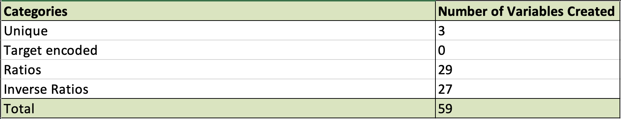

## **Dimensionality Reduction**

**Data Standardization Using Z-Scaling**

The data is scaled or standardized before applying PCA to ensure that the variables are on a similar scale. Scaling is important because PCA is sensitive to the relative magnitudes of the variables and Z scaling scales and centers the data. If the variables have different scales, those with larger values will dominate the PCA results, potentially leading to misleading outcomes. By scaling the data, we bring all variables to a common scale, typically by subtracting the mean and dividing by the standard deviation. This process ensures that each variable contributes equally to the PCA analysis, and the resulting PCs are not biased by the variable scales. Scaling also helps in cases where the variables have different units of measurement. In summary, scaling the data before PCA allows for a fair comparison and appropriate interpretation of the principal components, enabling us to focus on the underlying patterns and relationships within the dataset rather than being influenced by the variable scales.

**Dimensionality Reduction Using PCA (Principal Component Analysis)**

Principal Component Analysis (PCA) is a technique that identifies the most significant directions within a dataset and adjusts the coordinate system accordingly. These directions, known as Principal Components (PCs), establish a new coordinate system that is rotated from the original one. The PCs are mutually perpendicular and are determined based on the extent of variance in their respective directions. Each PC represents a rotated axis and is formed by combining the original variables linearly. Through PCA, correlated variables are amalgamated into a single direction, replacing them with a new variable that is a linear combination of the correlated ones. The PCs are arranged in order of their magnitude, as illustrated in the scree plot. By examining this plot, we can decide how many PCs to retain. Typically, we choose to keep only the initial few PCs to capture approximately 80% to 90% of the overall variance. The higher PCs are discarded, resulting in a reduction of dimensionality in the data matrix. Although all the records are still preserved, the dimensions have been considerably reduced.

The first plot is the scree plot that shows the decreasing variances of the PCs. By looking for a natural break in the scree plot we can decide to keep X% of the variance. In this plot it looks like we should keep at least 6 PCs. After that the additional amount of variance is small.

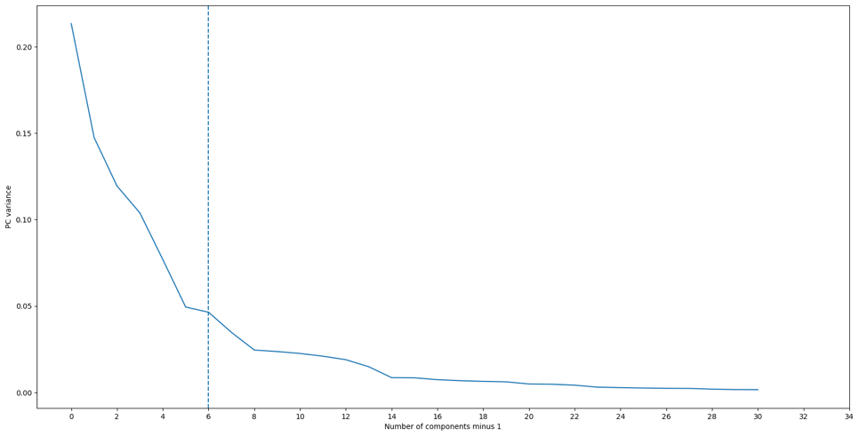

The below plot is that of the cumulative variance of the PCs. It shows how much of the total variance (spread) in the data we can retain by keeping some number of PCs. In this plot, we see that we can keep about 57% of all the variance if we keep only the first 3 PCs and about 80% of all the variance if we keep only the first 8 PCs.

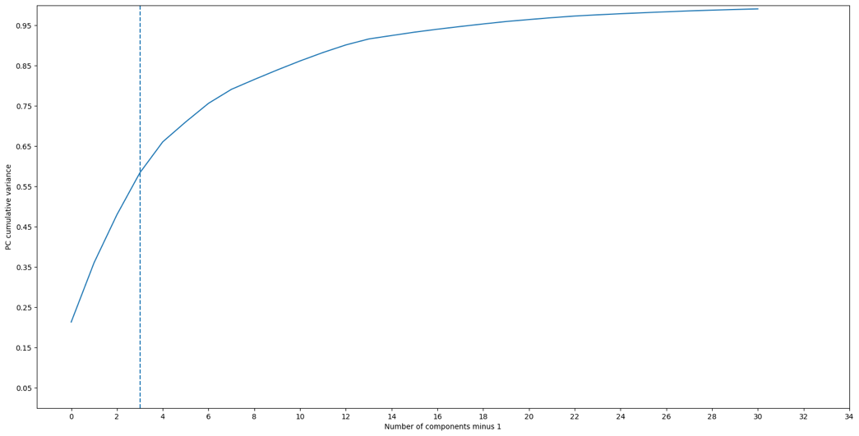

Finally, to ensure equal importance of the retained Principal Components (PCs), we z-scale them. This involves scaling the PCs to have a comparable range and variance. By z-scaling the PCs, we can effectively eliminate any bias or dominance that may arise due to differences in scale among the retained components, thus ensuring their equal significance in the analysis.

## **Anomaly Detection Algorithms**

**Two Score Algorithms**

Since we are detecting unsupervised anomalies, we search for unusual records. On building the right space i.e. variables, we can detect “outlierness” that is meaningful for this problem i.e the unusual records/points in that space. The 2 ways employed to find outliers are:

* Z-scaling: The original variables have very different scales but post z-scaling the data is now a cloud around the origin with the same scaling for all dimensions. The process described involves scaling the dimensions of the data using z-scores to ensure consistency. Principal Component Analysis (PCA) is then performed to reduce the dimensionality by selecting only the top principal components. If desired, another round of z-scaling can be applied to make the remaining principal components equally important. These transformed variables, referred to as z-scores, indicate the outlierness of each variable explicitly. By starting with expert variables and going through the steps, the data becomes centered, uncorrelated, and similarly scaled. The z-scores for each record can be summed up using a Minkowski distance to determine the overall unusualness of that record.

Zscale where x is the point, μ is the mean and σ is the standard deviation:



Minkowski distance, which is the first fraud score method:

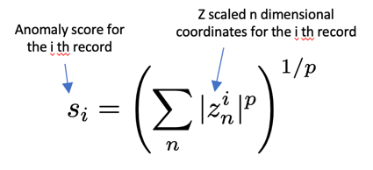

Reasonable choices of p are 1, 2 or 3

* Autoencoder: This is a neural network used in property fraud detection to identify anomalies in property data. It is a model trained to output the original vector input. After the model is trained, the difference (error) between the original input vector and the model output vector is considered as the fraud score for that record.

After standardizing the data using z-scores, performing PCA for dimensionality reduction, and applying another round of z-scaling, the autoencoder is trained using the complete dataset. During training, the autoencoder learns to reconstruct the data records accurately, capturing the patterns present in most of the data. Records that are not well-reproduced by the autoencoder are considered unusual, which is indicative of potential fraud. Hence, the measure of the reconstruction error serves as a fraud score, as it quantifies the level of unusualness for each record.

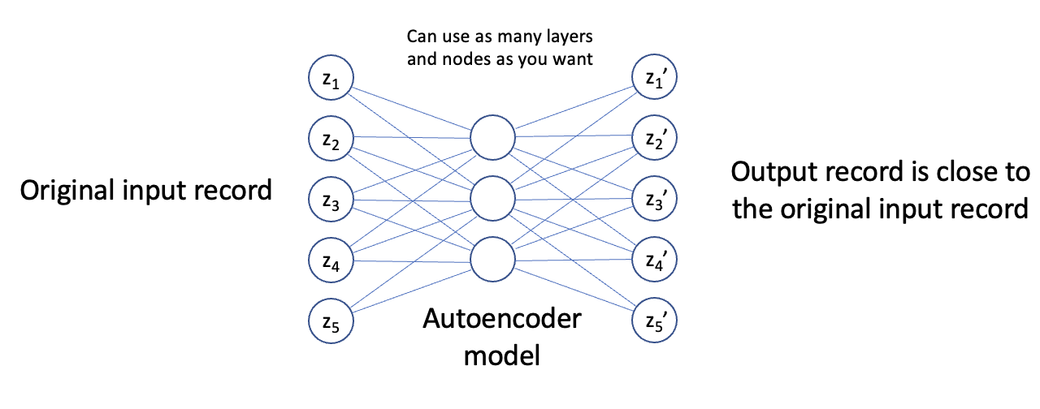

The second fraud score which is the autoencoder score can be measured as:

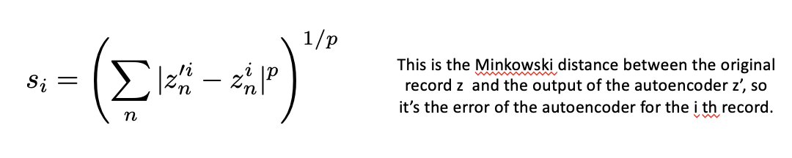

**Combining the 2 scores**

To standardize and combine the outputs from the 2 score methods, we use a technique called rank order scaling. This involves transforming a variable or score into its quantile rankings. Firstly, the records are sorted based on the score we want to scale. Then, the records are divided into equal count bins, and the variable or score is replaced with the bin number or the rank order of the record after sorting. This process ensures that all variables or scores are on an equal scale. Once each score has been rank-ordered, they can be combined using methods such as weighted average, maximum, minimum, or other aggregation techniques, allowing for a unified analysis of the data.

## **Results**:

Following the creation of the unsupervised model, the records are sorted based on a combined score, and the top records are investigated to understand why they are considered suspicious and whether they are legitimate. While many of the top anomalous records may turn out to be unusual but acceptable.

To identify unusual records, one can examine the Z-scaled variables of the top records. Z-scores indicate the number of standard deviations a record deviates from the mean. By calculating Z-scores for each variable, we can easily identify which variables have exceptional values in the dataset. A high Z-score suggests that the corresponding variable has an unusual value compared to the average. Furthermore, creating heatmaps using the Z-scaled variables helps visualize which variables contribute to the high scores. Heatmaps provide a graphical representation of the relationships between variables, showcasing the variables responsible for driving the high scores in the dataset. This visualization aids in understanding the underlying patterns and identifying the specific variables that contribute to the unusual records. By analyzing the Z-scaled variables and utilizing heatmaps, we can effectively pinpoint the variables with unusual values, allowing for further investigation and exploration of these exceptional records.

Values unusually large for that zip code

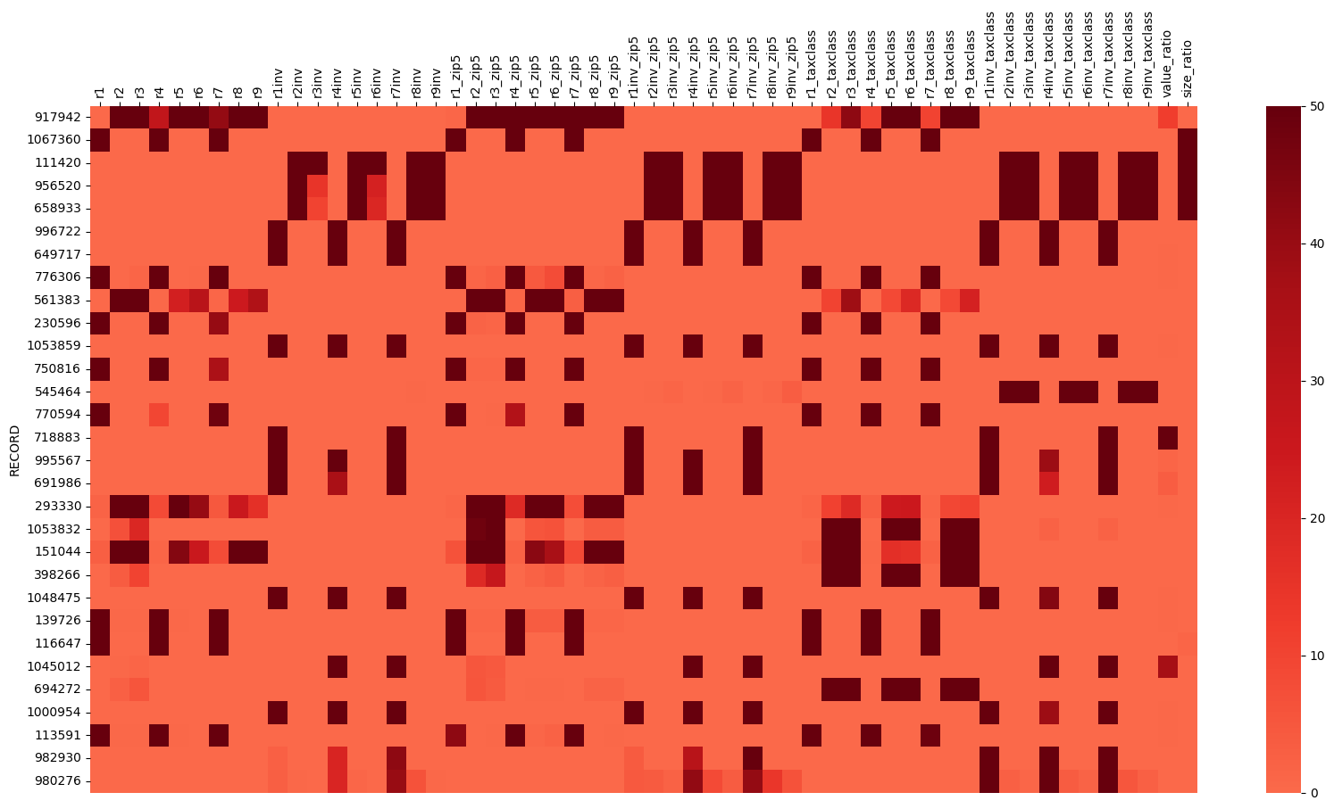

Values unusually large

**Case Studies**

## **Property 1**



As per the dataset this address is supposed to have a building with 5-6 stories. However, on investigating the address, we find that there is no building at the mentioned address. It seems to be a parking lot near the Brooklyn Queens Expressway. Additionally, AVLAND is underreported.

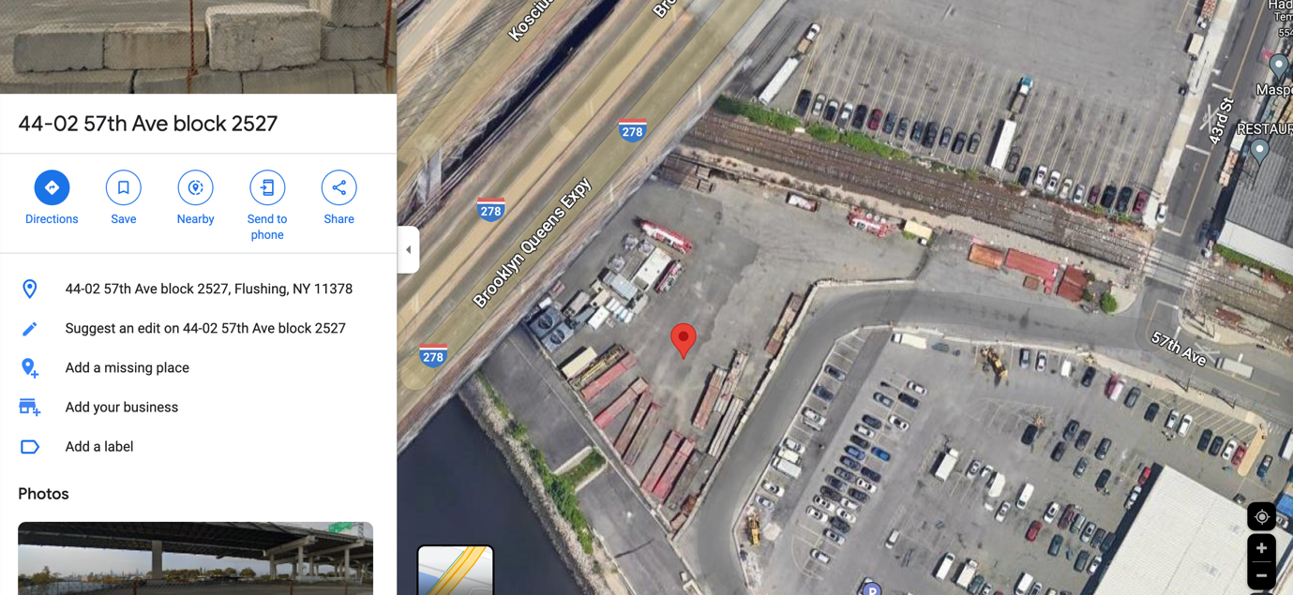

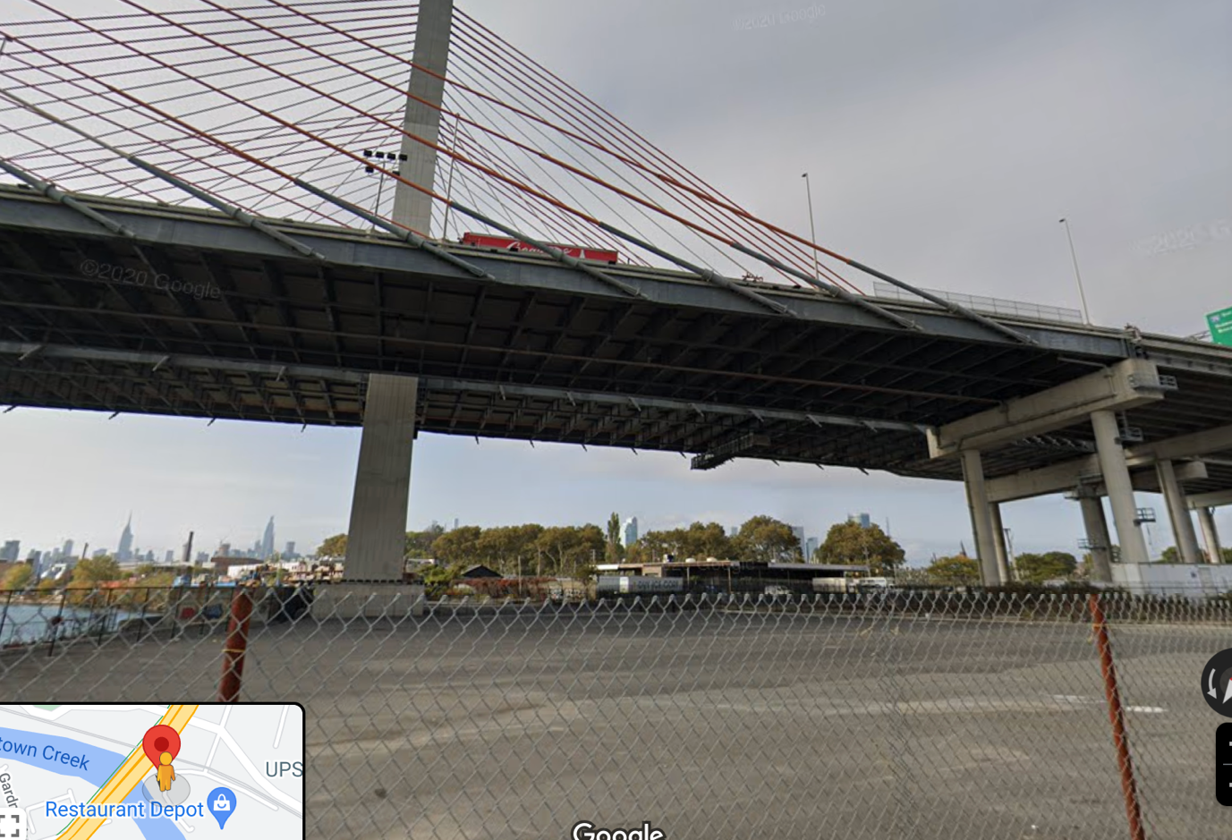

## **Property 2**



The dataset mentions this record to be a building with 4 stories. However, on investigating the address, we find it to be a residential community with bungalow style houses. The mentioned property does not have more than 1 story. Additionally, BLDFRONT and AVLAND values are also underreported.

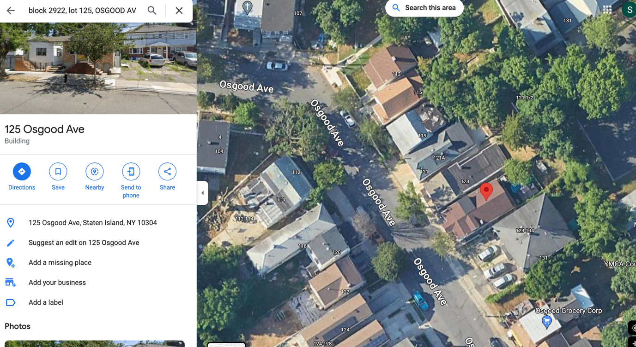

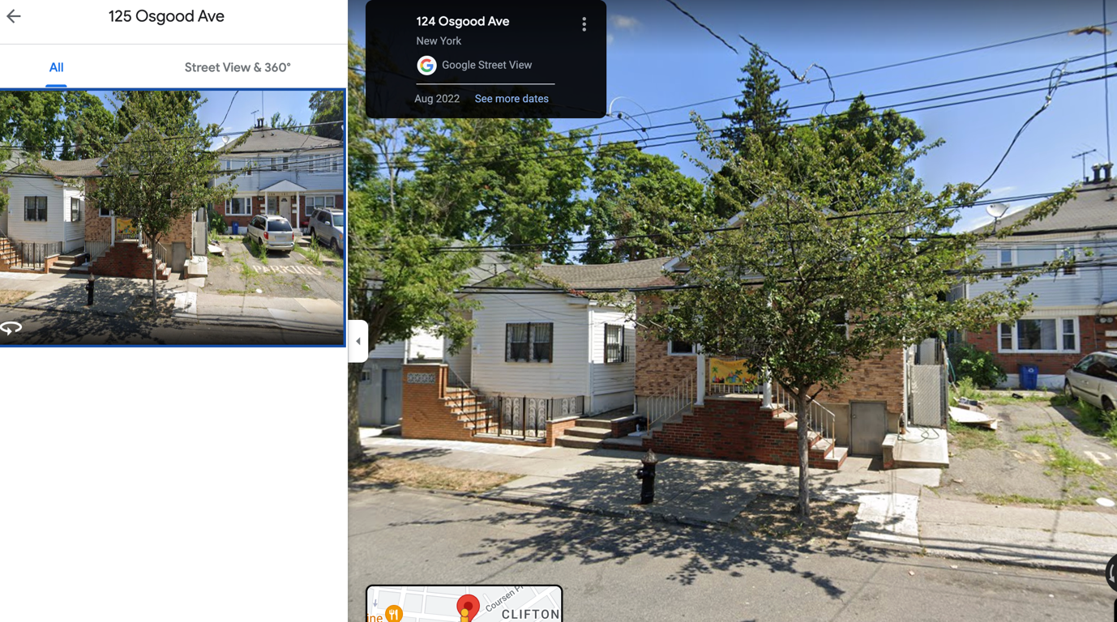

## **Property 3**



The dataset mentions this record to be a building with 4 stories. However, on investigating the address, we find it to be a residential community with bungalow style houses. The mentioned property does not have more than 1 story. Additionally, LTFRONT and BLDFRONT are underreported.

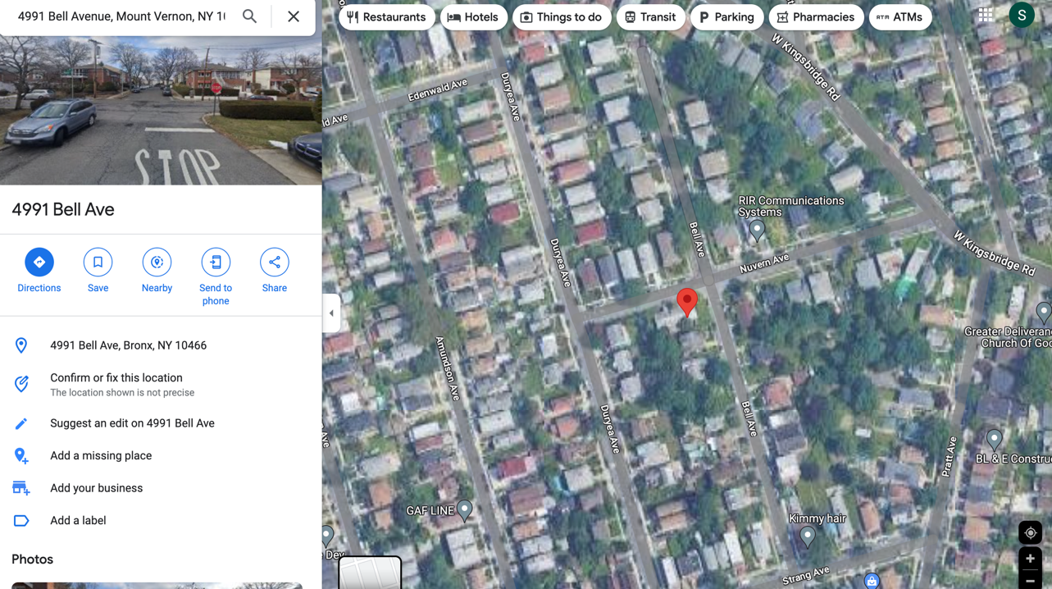

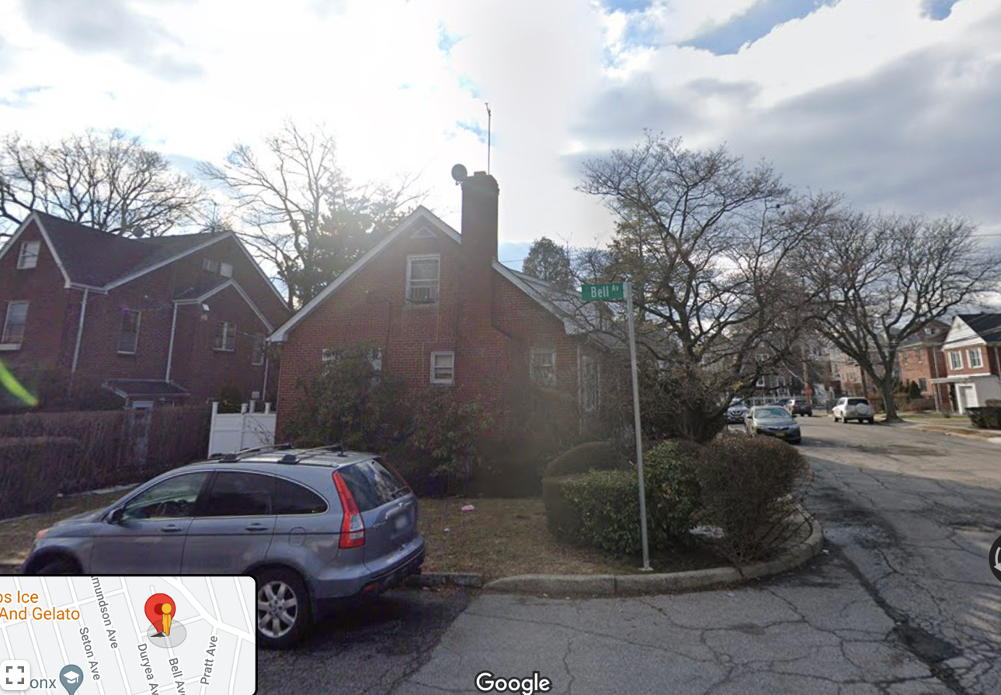

## **Property 4**



The property is a building that appears to have the reported number of stories. However, the AVTOT is extremely low for a building with 15+ stories in New York. This property needs to be investigated.

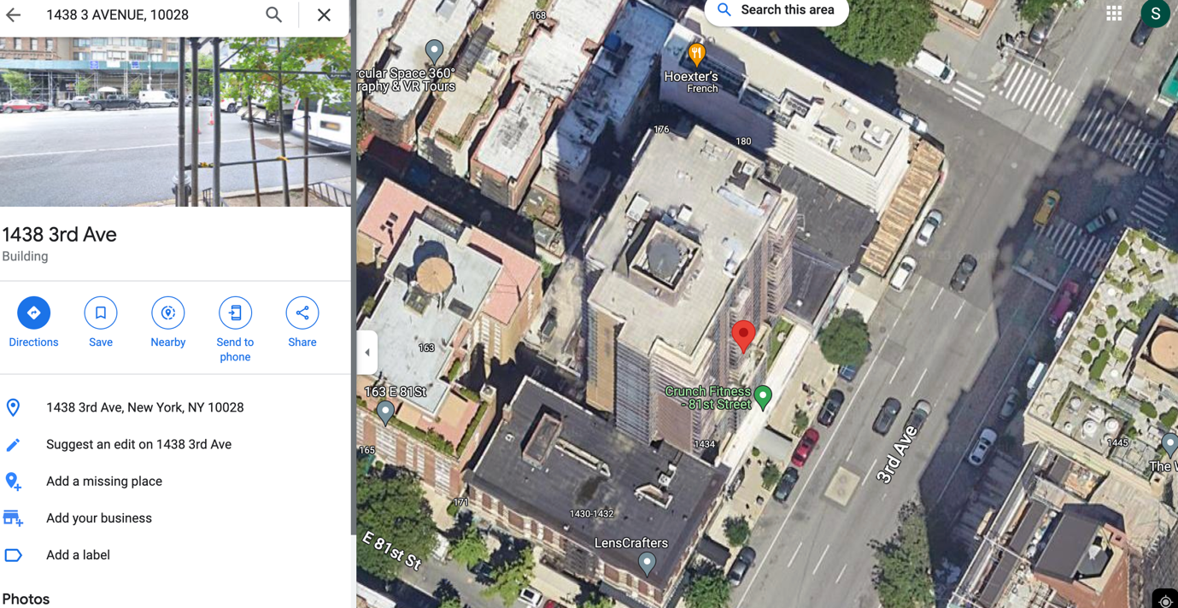

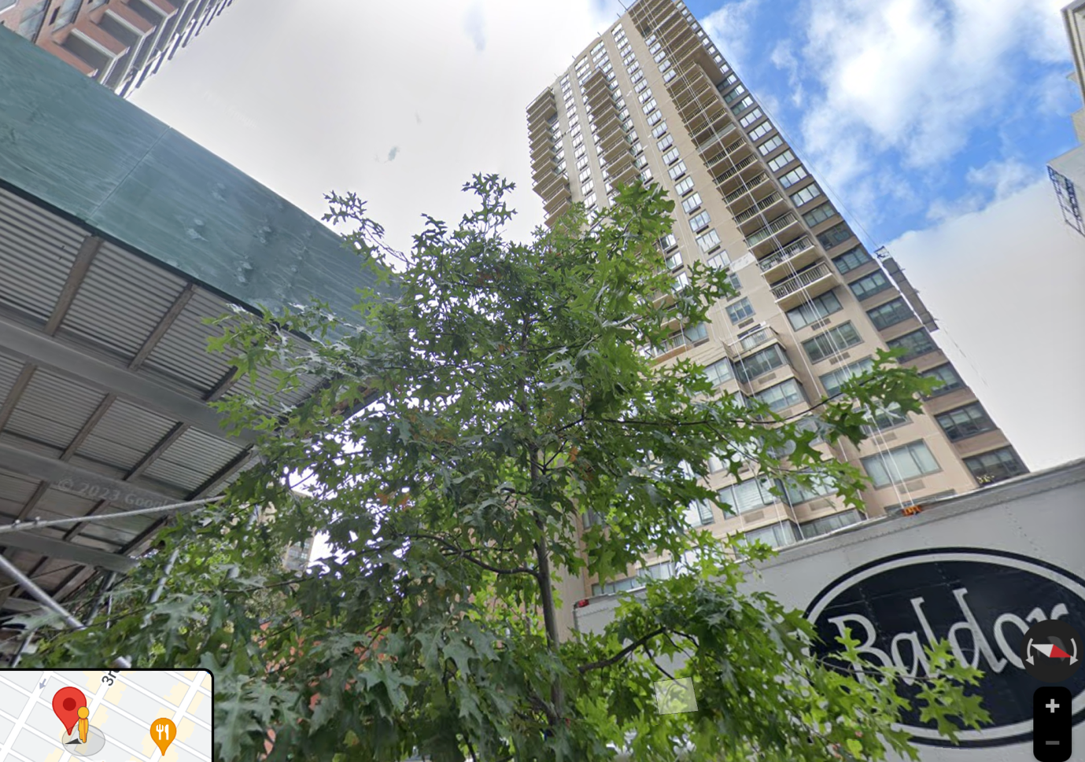

## **Property 5**



The dataset mentions this record to be a building with 4 stories. However, on investigating the address, we find it to be a residential community with bungalow style houses. The mentioned property does not have more than 2 stories. Additionally, LTFRONT and BLDFRONT are underreported.

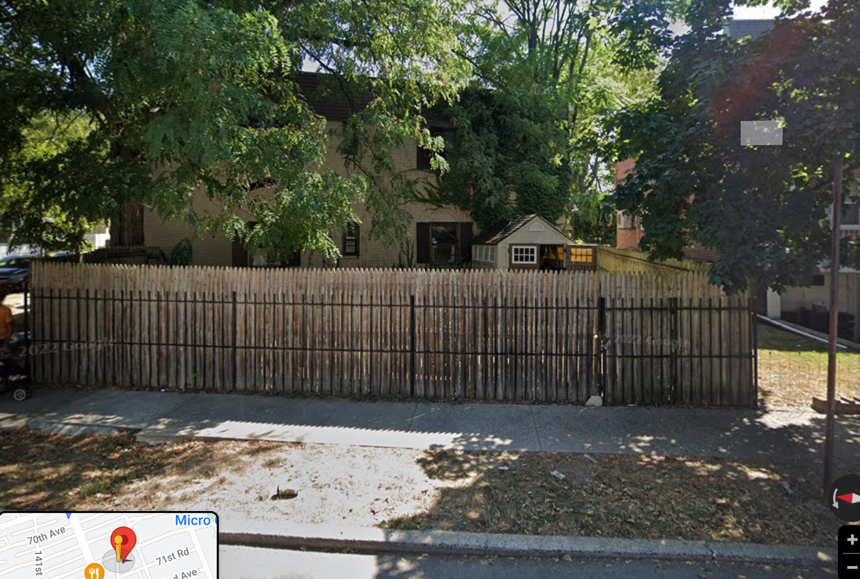

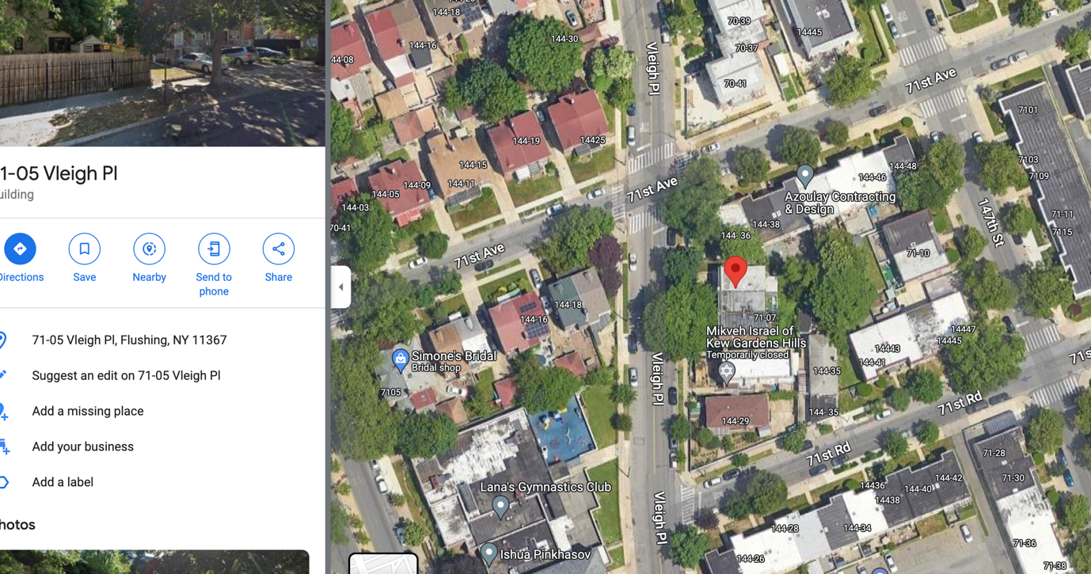

## **Summary**

As the dataset lacks fraud labels or dependent variables, traditional measures for classification models cannot be used, such as KS, detection rate, and false positives. Therefore, the model is constructed by leveraging the professor’s guidance, particularly in the development of variables, data exclusions, and imputations. Following the creation of variables for the unsupervised model, the variables are z-scaled to center the data and bring all variables to a common scale to not include any variable scale bias in PCA.

PCA identifies significant directions in data and adjusts the coordinate system accordingly. These Principal Components (PCs) form a new rotated axis by combining variables. Correlated variables are replaced by a single variable and the PCs are sorted by magnitude. We retain a few initial PCs to capture most variance (80-90%). Higher PCs are discarded, reducing dimensionality while preserving records. To ensure equal importance of the retained Principal Components (PCs), we z-scale them to effectively eliminate any bias or dominance that may arise due to differences in scale among the retained components, thus ensuring their equal significance in the analysis.

These transformed variables, referred to as z-scores, indicate the ‘outlierness’ of each variable explicitly. The z-scores for each record can be summed up using a Minkowski distance to determine the overall unusualness of that record and this is the first fraud score. Additionally, the autoencoder is trained on the transformed variables to reconstruct the data records accurately, capturing the patterns present in most of the data. Records that are not well-reproduced by the autoencoder are considered unusual, which is indicative of potential fraud. Hence, the measure of the reconstruction error serves as the second fraud score, as it quantifies the level of unusualness for each record. To standardize and combine scores, rank order scaling is used. It involves transforming scores into quantile rankings. Records are sorted, divided into bins, and replaced with bin numbers or rank order. This equalizes scales and the scores can be combined using aggregation techniques for unified analysis.

The records are sorted based on a combined score, and the top records are the potentially fraudulent records which are investigated to understand why they are considered suspicious and whether they are legitimate. While many of the top anomalous records may turn out to be unusual but acceptable, adjustments are made to the algorithm and processes to align with the clients' interests. A list of the top few hundred records is generally provided to the clients for examination, and their feedback is considered to refine the model, especially in terms of exclusions and variables. This iterative process continues, incorporating feedback from the clients until they express satisfaction with the results, indicating that the model is performing well and identifying genuinely interesting findings. Typically, this iterative refinement requires two or three iterations, although in some cases, it may be accomplished without any iterations, depending on the accuracy of the initial variables built based on expert input.

## **Appendix**

**Dataset Description:** The dataset is the Property Valuation and Assessment Data released by the Department of Finance and consists ofReal Estate Assessment Property data that has 1070994 records and 32 fields. It has 14 numeric fields and 18 categorical fields.

**Summary Tables:**

**Numeric Fields:**



**Categorical Fields:**



Where:

% Populated: percentage of records present

# Zeros: Number of zeros

# Unique Values: Number of unique values

**Data Types of the Fields**



**Visualization of Each Field**

**RECORD**

Description: Unique positive integer that represents the record number for all dataset entries, from 1 to 1070994.

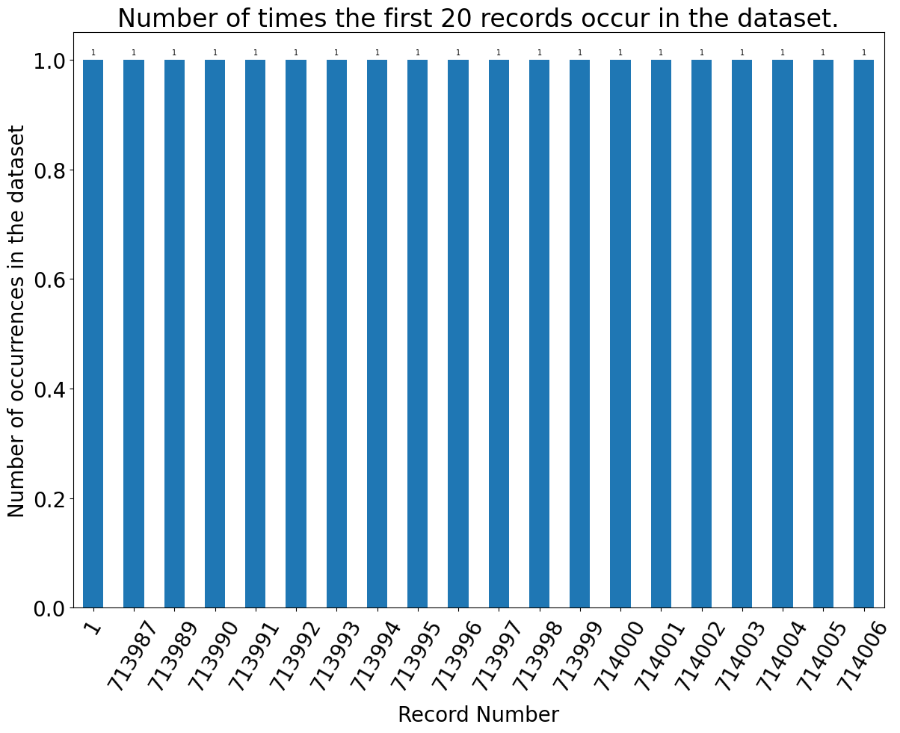

**BBLE**

Description: Unique positive integer that represents file key and has 1070994 unique values and ranges from 1000010101 to 5080500094. The file key is made of Borough, Block, Lot and Easement code respectively.

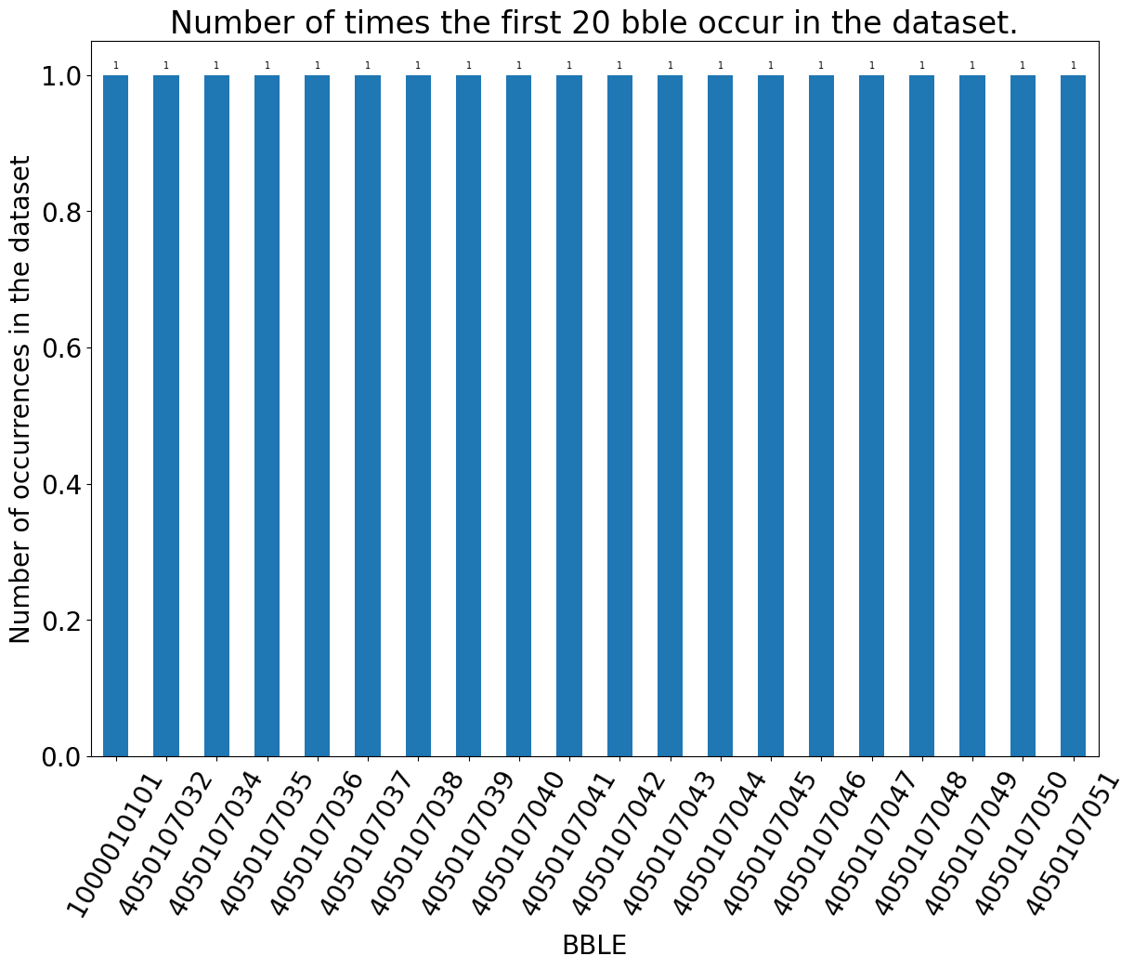

**BORO**

Description: Unique positive integer that has 5 unique values and ranges from 1 to 5, where 1 = Manhattan, 2 = Bronx, 3 = Brooklyn, 4 = Queens, 5 = Staten Island

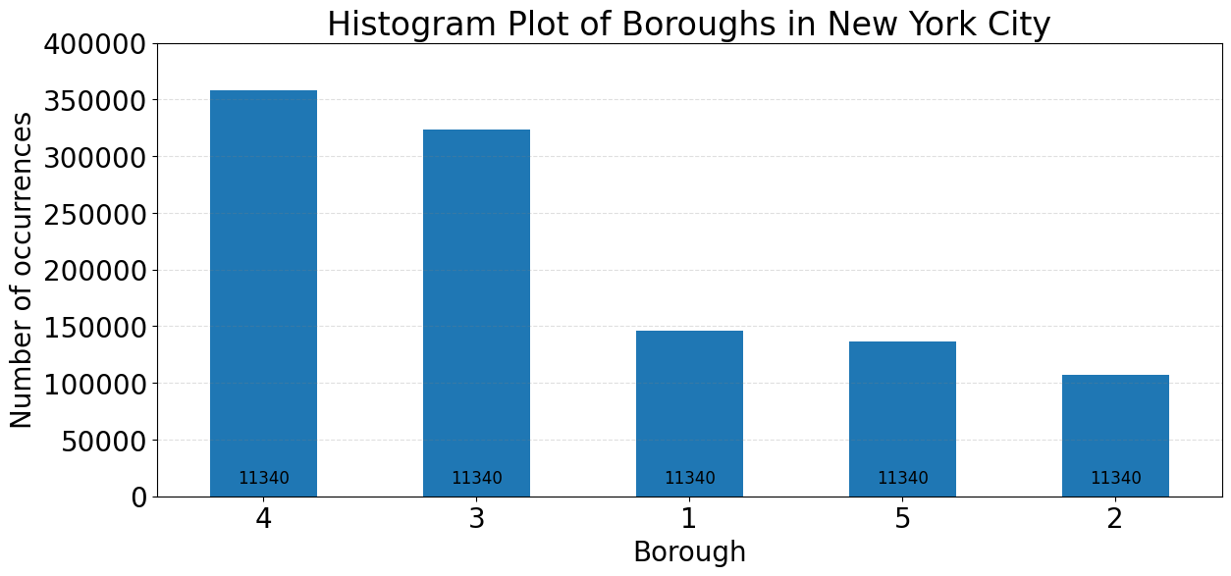

**BLOCK**

Description: Unique positive integer representing the blocks in a borough and it has 13984 unique values that range from 1 to 16350. The valid ranges are:

Manhattan: 1 to 2255,

Bronx: 2260 to 5958,

Brooklyn: 1 to 8955,

Queens: 1 to 16350,

Staten Island: 1 to 8050

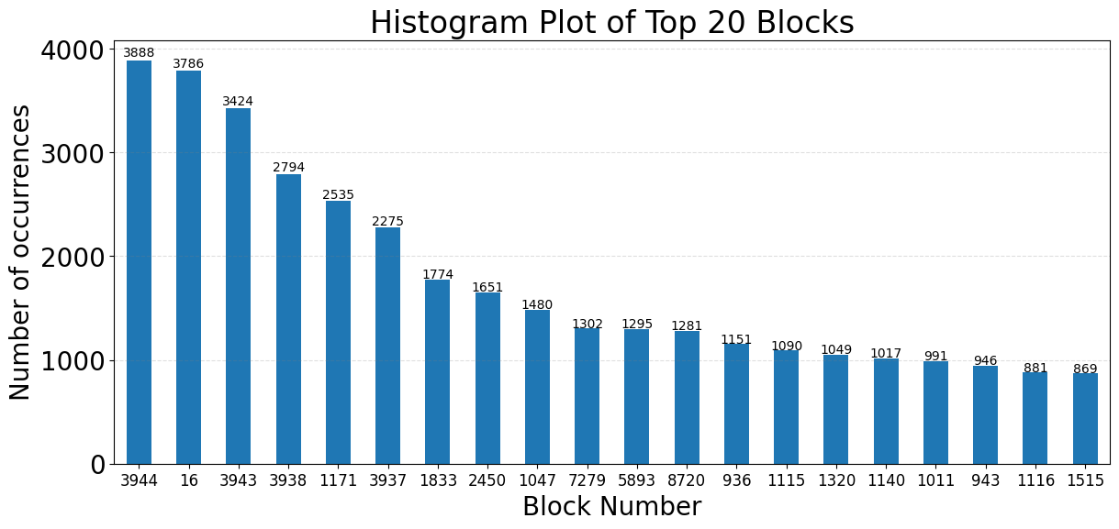

**LOT**

Description: Unique positive integer representing lot number and has 6366 unique values and ranges from 1 to 9978.

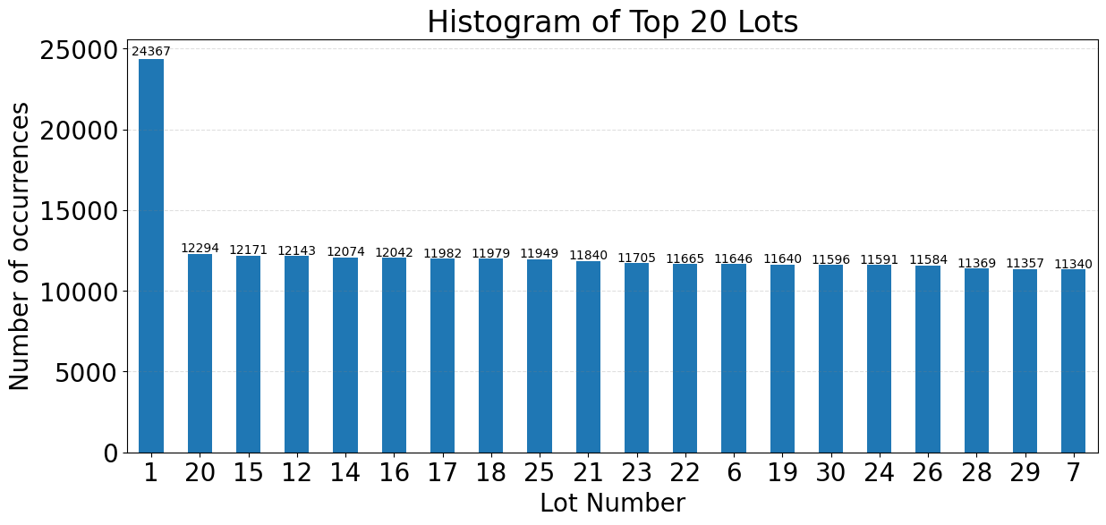

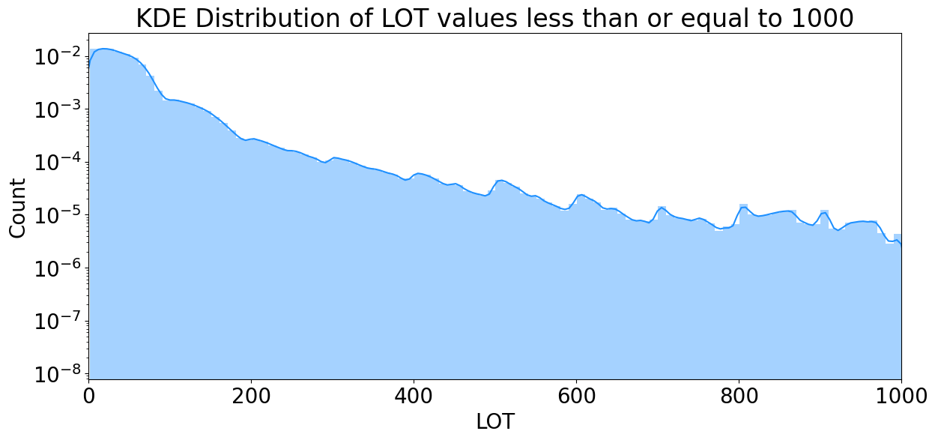

## EASEMENT

Description: Object data type that has 12 unique values that are alphabets. For example:

Space = No Easement, A = Air Easement, B = Non-Air Rights, E = Land Easement, F Thru M are duplicates of E, N = Non-Transit Easement, P = Pier, R = Railroad, S = Street, U = U.S. Government

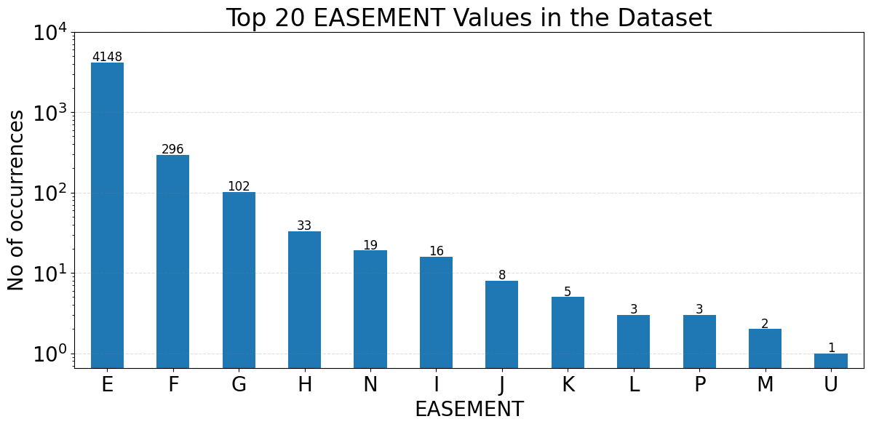

**OWNER**

Description: Object data type that has 863348 unique values that represent the owners associated with the property.

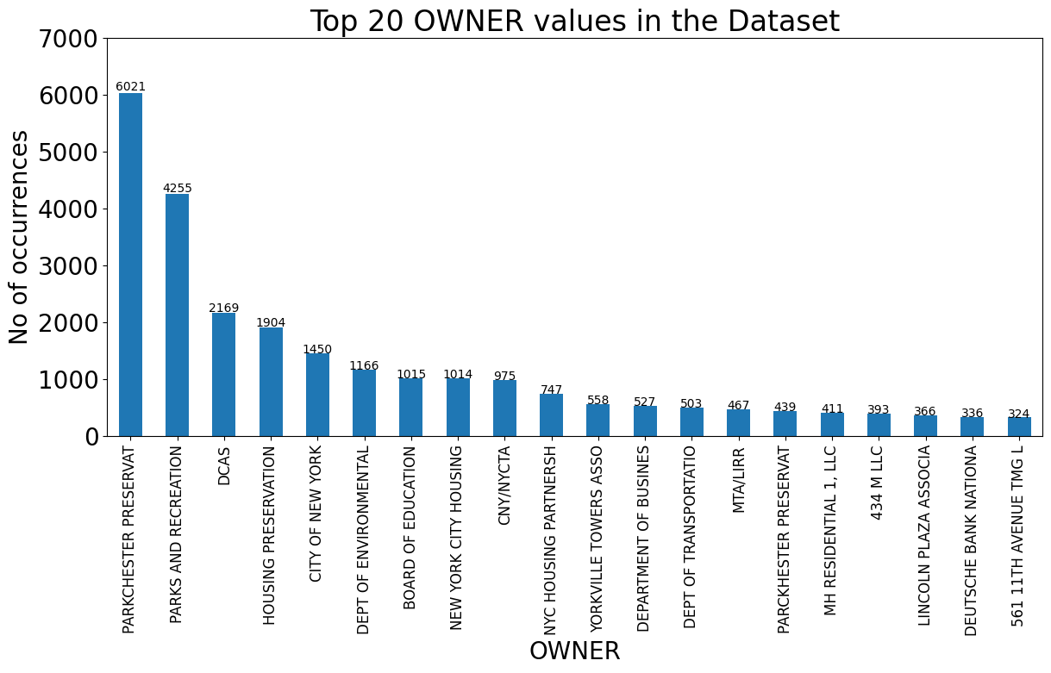

## BLDGCL

Description: Object data type representing Building Class and has 200 unique values that represent the building class associated with the property.

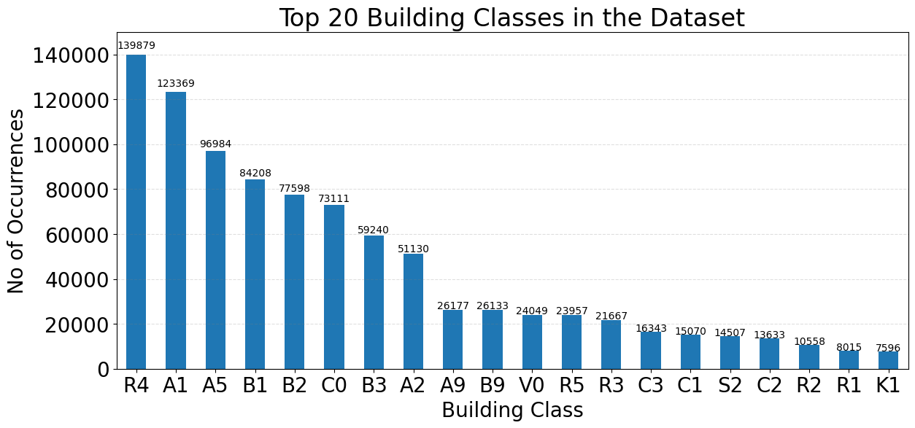

## TAXCLASS

Description: Object data type that has 11 unique values that represent the tax class. For example:

1 = 1 - 3 Unit Residence, 2 = Apartments, 2A = 4, 5, or 6 Units, 3 = Utilities, 4 = All Others

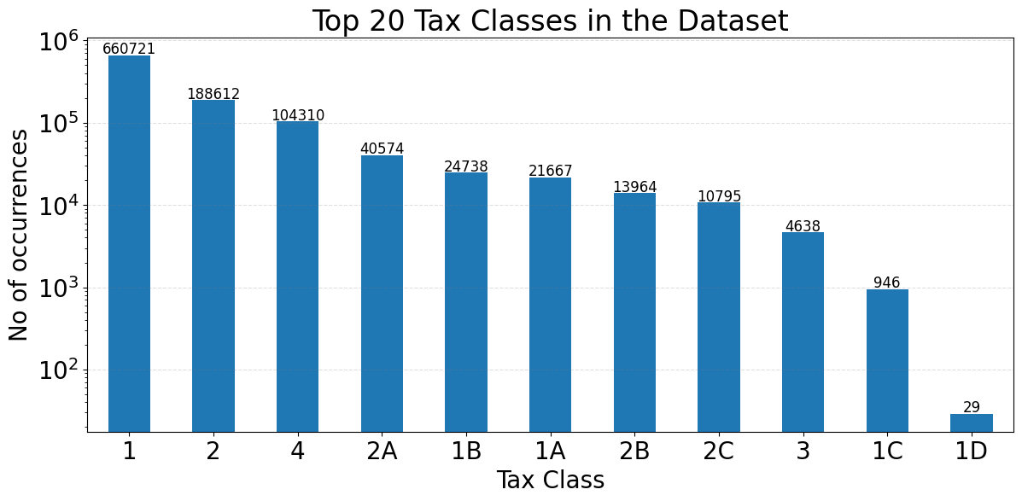

## LTFRONT

Description: Integer data type representing Lot Width that has 1370 unique values that ranges from 0 to 9999.

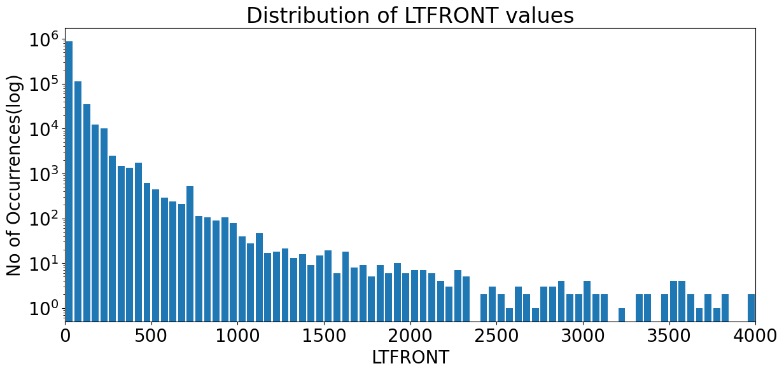

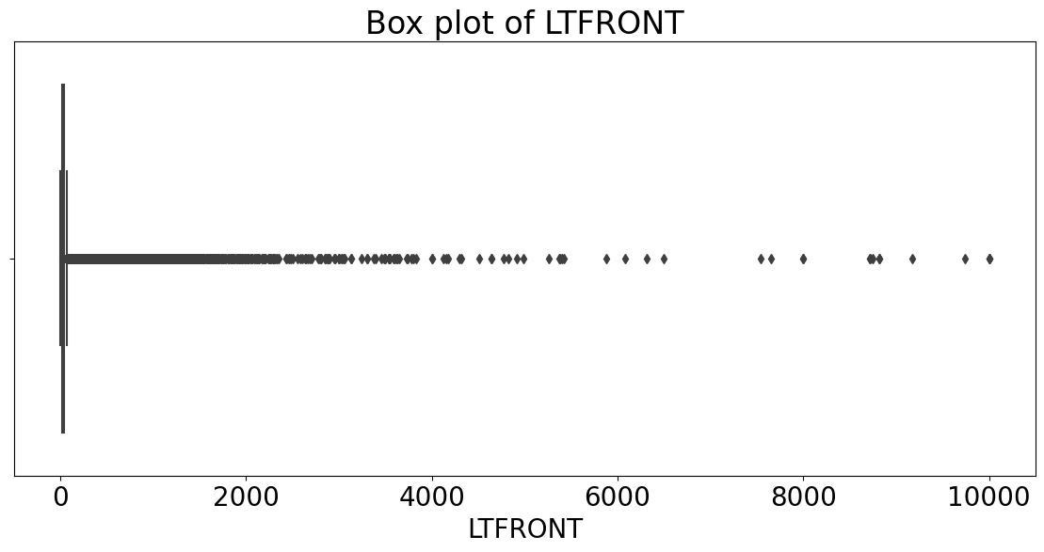

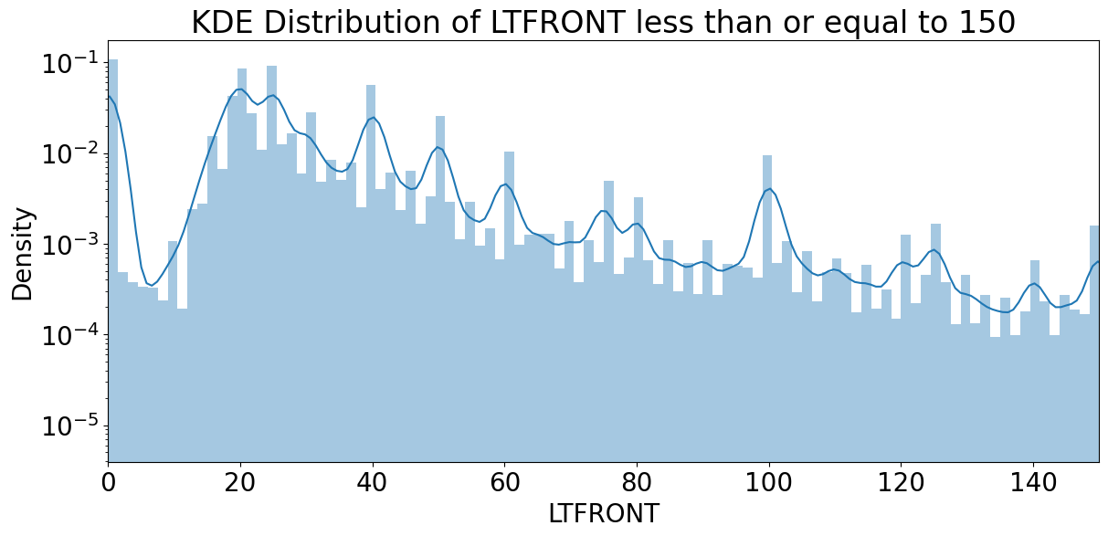

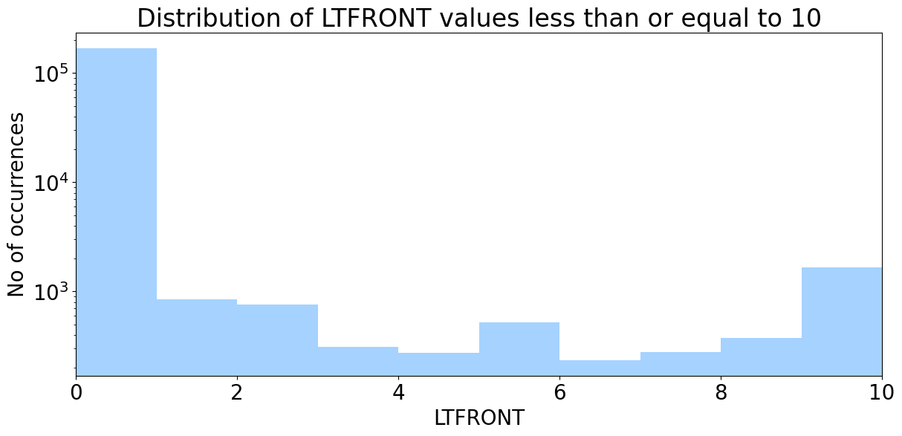

## LTDEPTH

Description: Integer data type representing Lot Depth that has 1370 unique values that ranges from 0 to 9999.

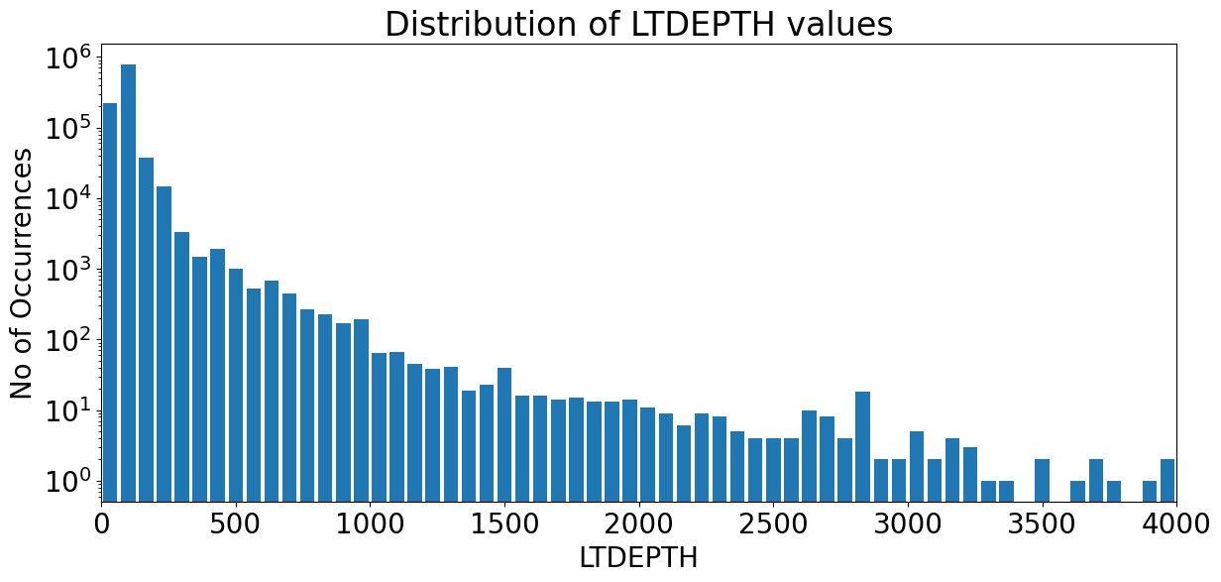

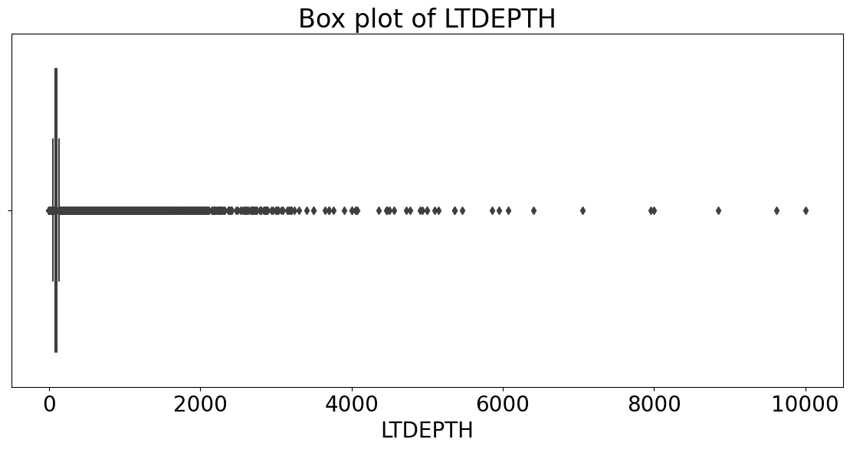

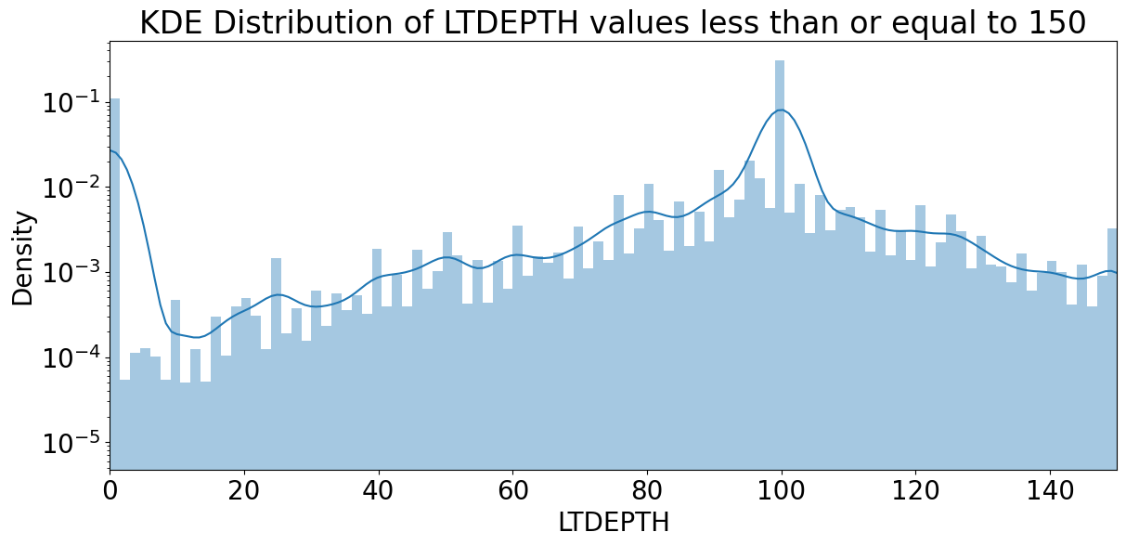

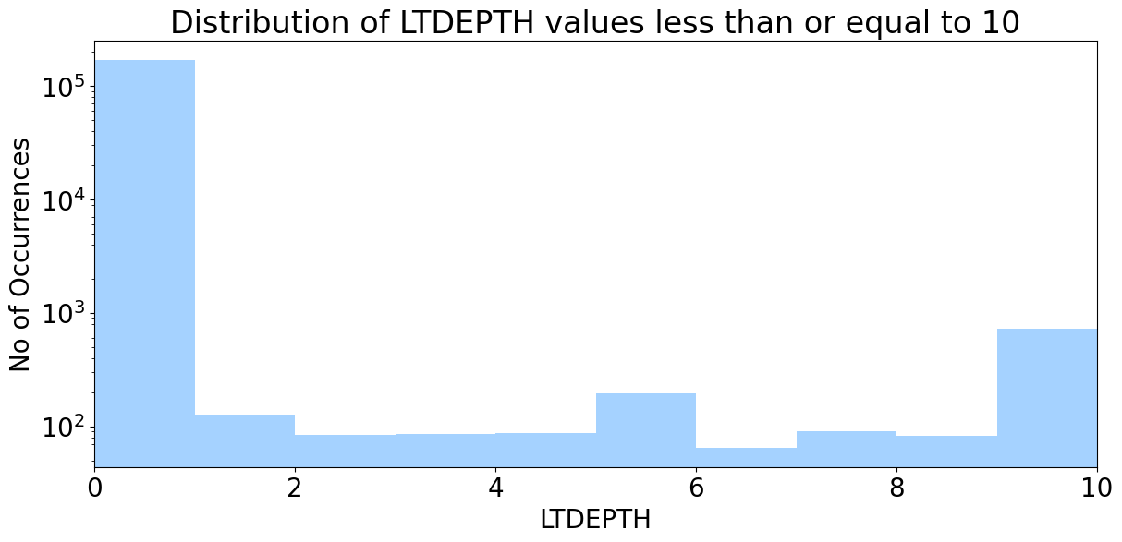

## EXT

Description: Object data type representing Extension Indicator that has 4 unique values G, E, EG and NaN.

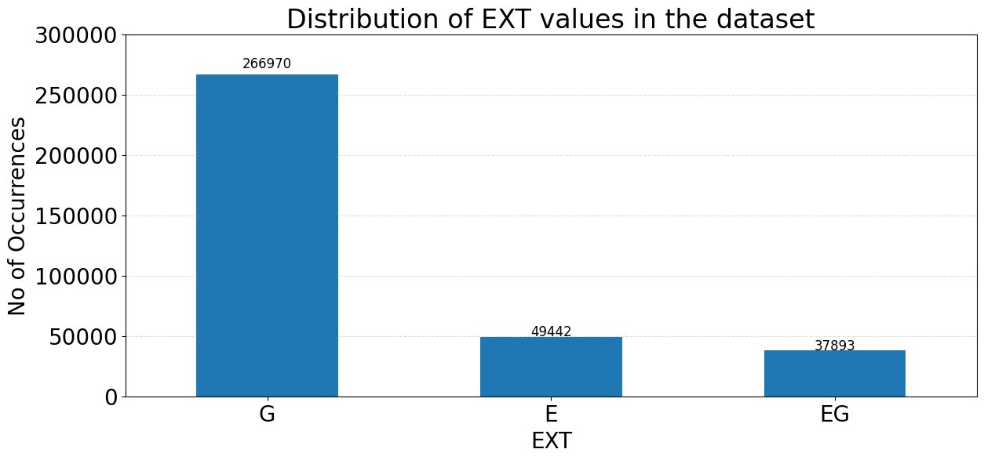

## STORIES

Description: Integer data representing the number of stories in the building and it has 112 unique values that range from 1 to 119.

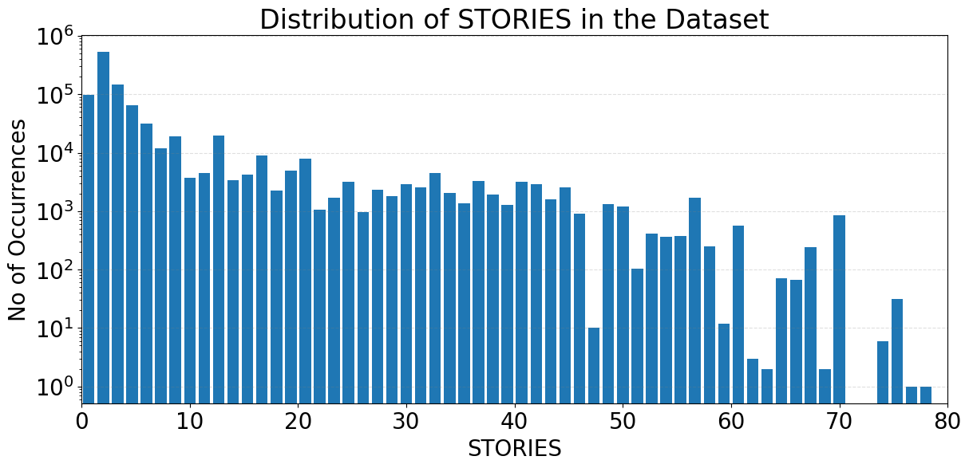

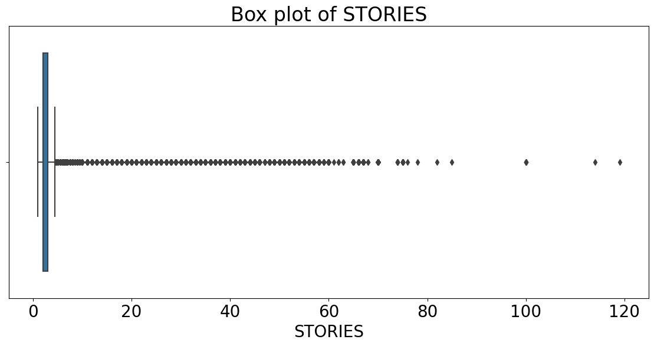

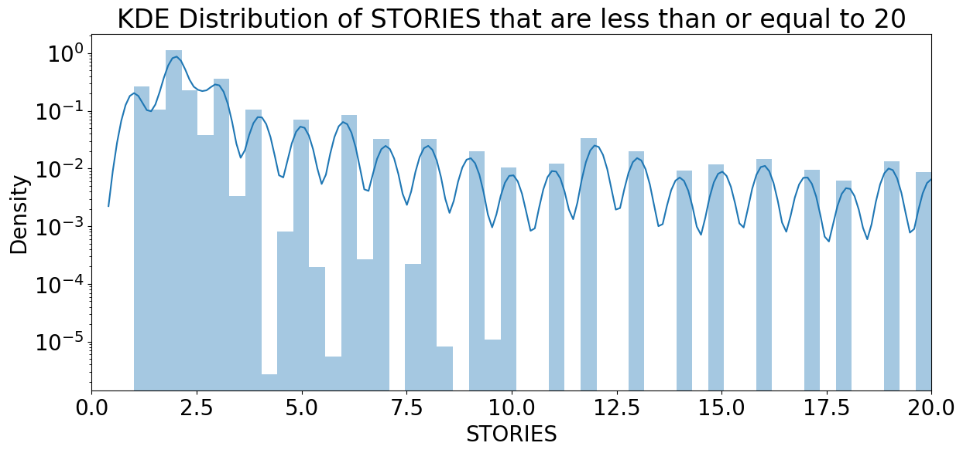

## FULLVAL

Description: Float data representing the market value of the property and has 109324 unique values that range from 0 to 6.150 billion.

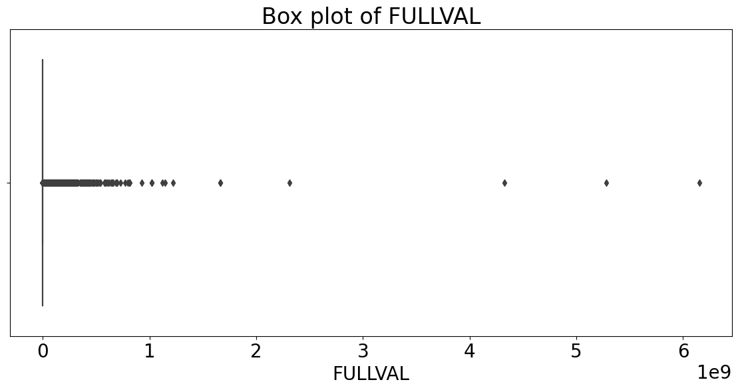

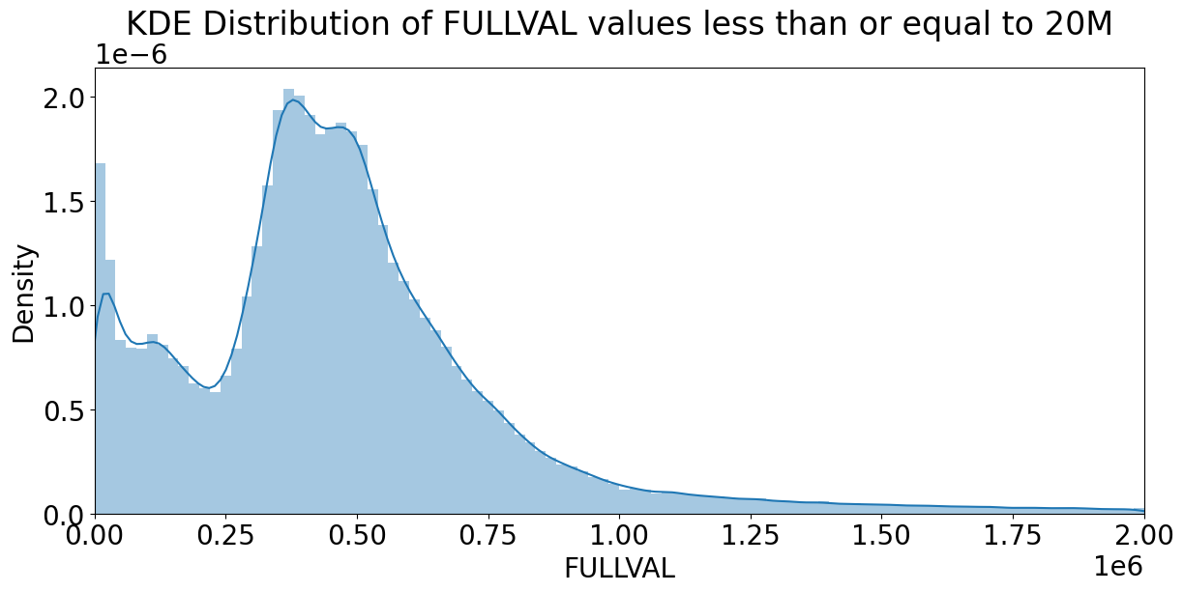

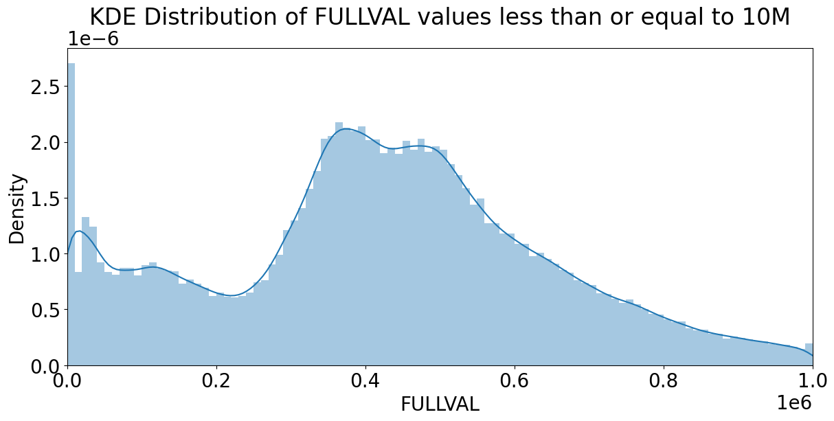

## AVLAND

Description: Float data representing Actual Land Value and has 70921 unique values that range from 0 to 2.6685 Billion units.

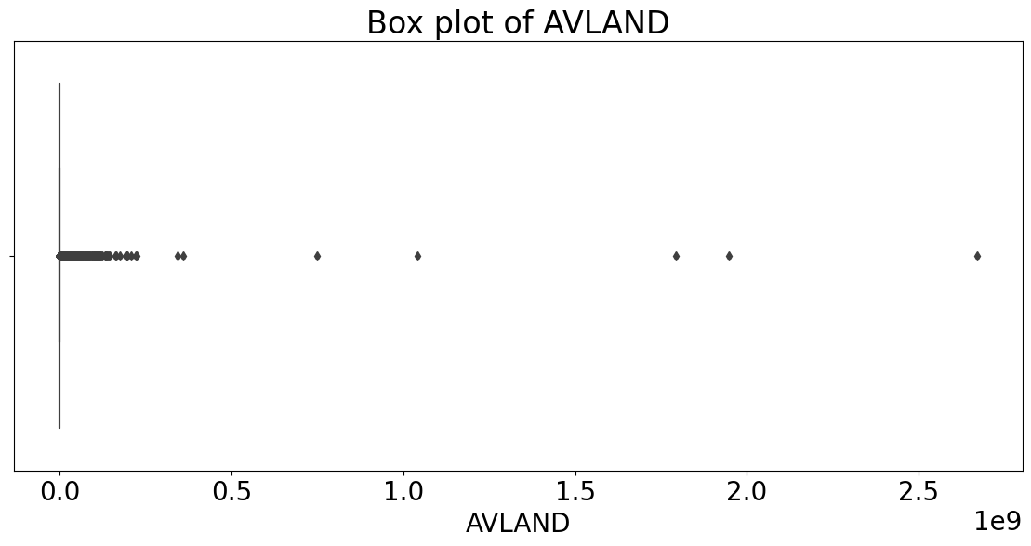

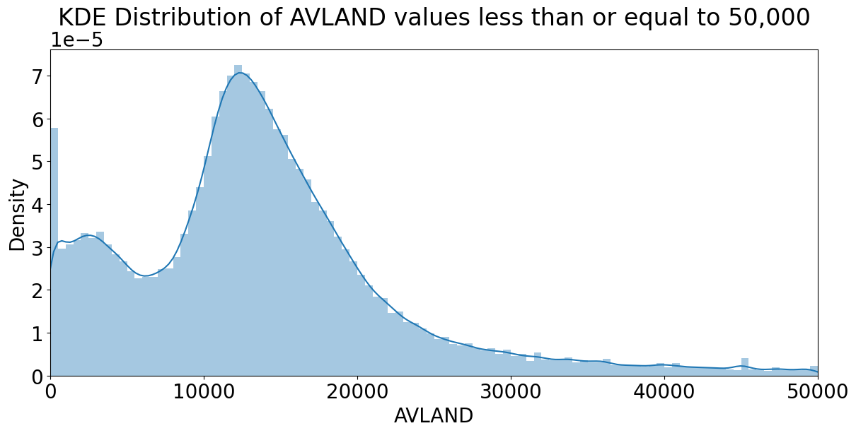

## AVTOT

Description: Float data representing Actual Total Value and has 112914 unique values that range from 0 to 4668308947.

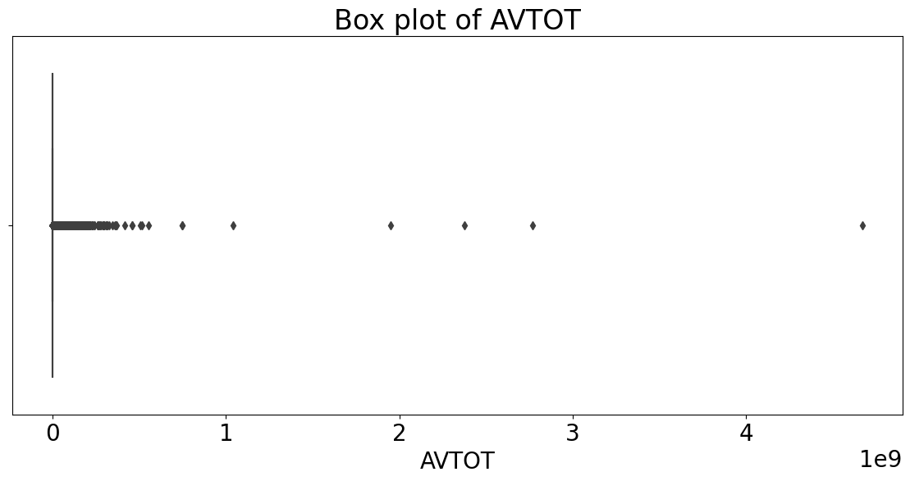

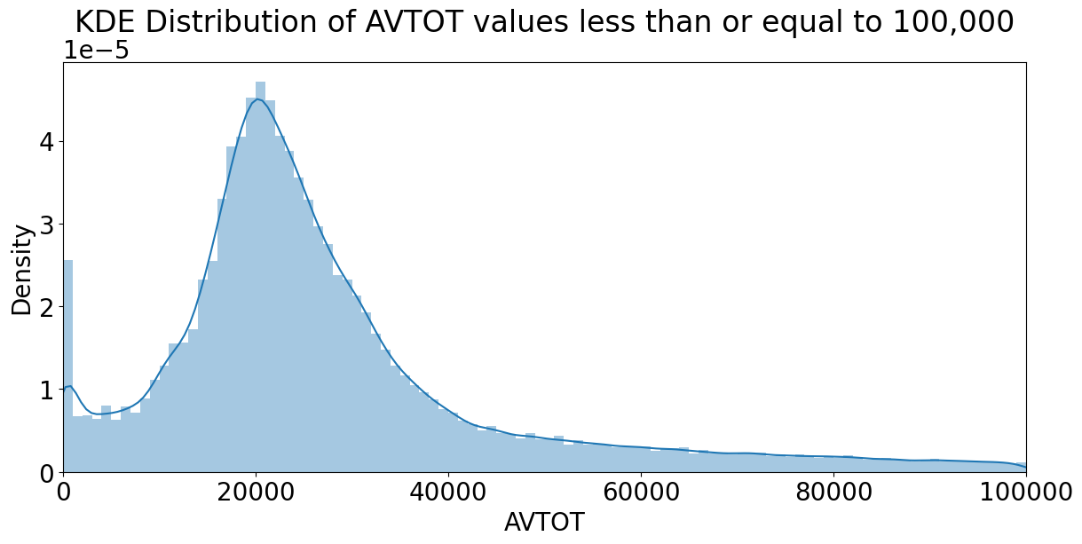

## EXLAND

Description: Float data representing Actual Exempt Land Value that has 33419 unique values that range from 0 to 2668500000.

**

## EXTOT

Description: Float data representing Actual Exempt Land Total that has 64225 unique values that range from 0 to 4668308947.

**

## EXCD1

Description: Float data representing Exemption Code 1 that has 130 unique values that range from 1010 to 7170.

**

## STADDR

Description: Object data that represents street address and has 839281 unique values.

## ZIP

Description: Float data that represents the zip code and has 197 unique values that range from 10001 to 33803.

## EXMPTCL

Description: Object data that has 15 unique values like X3, X1, NaN, X5, X6, X7, X2, X4, X8, X9, VI, KI, A9, R4, 5.

## BLDFRONT

Description: Integer data representing Building Width and has 612 unique values ranging from 0 to 7575.

**

**

## BLDDEPTH

Description: Integer data representing Building Depth and has 621 unique values ranging from 0 to 9393.

**

**

## AVLAND2

Description: Float data representing Transitional Land Value and it has 58592 unique values ranging from 3 to 2371005000.

## AVTOT2

Description: Float data representing Transitional Total Value and it has 111361 unique values ranging from 3 to 4501180002.

## EXLAND2

Description: Float data representing Transitional Exemption Land Value and it has 111361 unique values ranging from 3 to 4501180002.

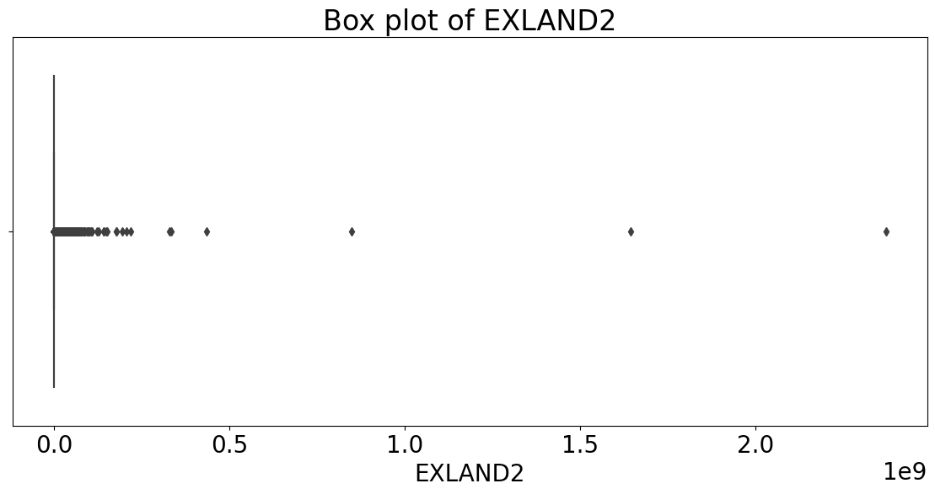

**

**

## EXTOT2

Description: Float data representing Transitional Exemption Land Total and it has 48349 unique values ranging from 7 to 4501180002.

**

## EXCD2

Description: Float data representing Exemption Code 2 and it has 61 unique values ranging from 1011 to 7160.

## PERIOD

Description: Object data representing Assessment Period that has 1 unique value : FINAL .

## YEAR

Description: Object data representing Assessment Year that has 1 unique value : 2010/11 .

## VALTYPE

Description: Object data that has 1 unique value : AC-TR .

